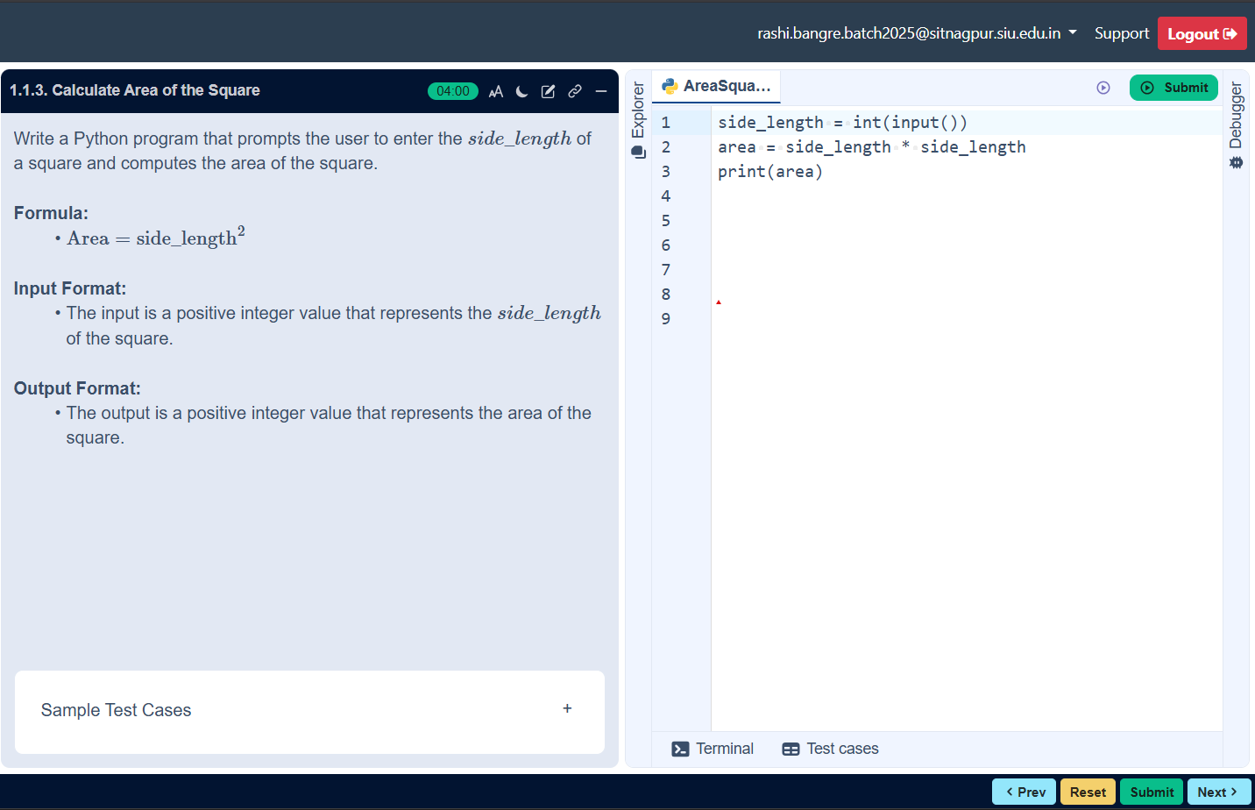
FLOWCHART

ALGORITHM
Step 1: Start
Step 2: Input side _ length
Step 3: Calculate area=
Side _ length*side _ length
Step 4: Print area
Step 5: Stop

AREA OF THE SQUARE
